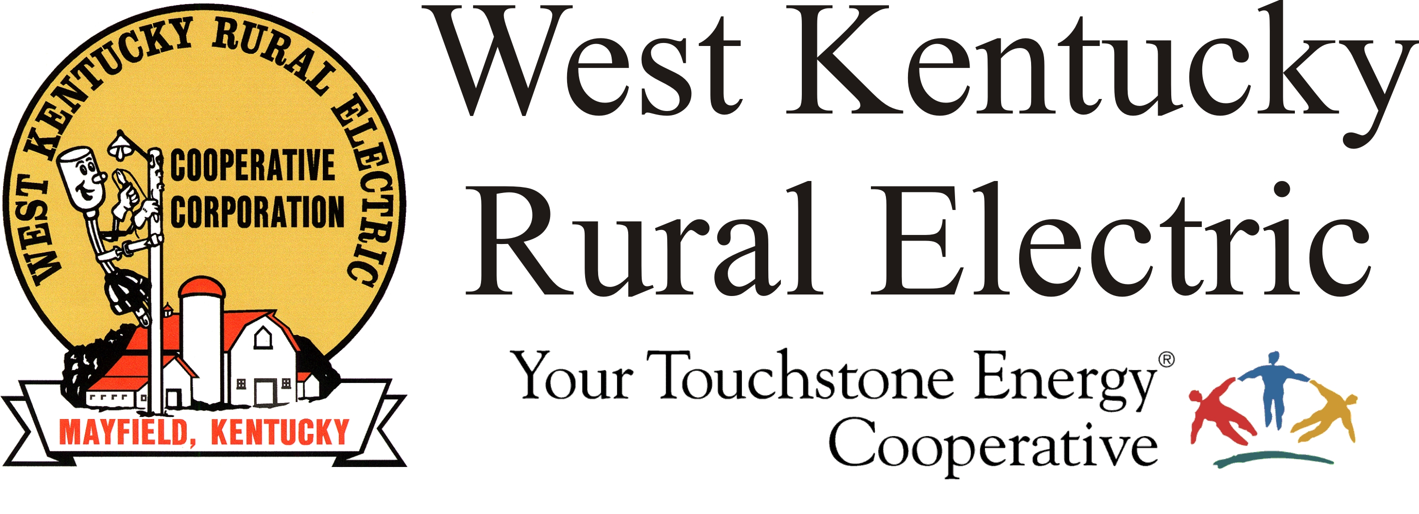

West Kentucky RECC Saturday Storm Damage Update

(Mayfield, Ky.) Dec. 18, 2021 (10:00 a.m.) – West Kentucky Rural Electric Cooperative is now in the final and, in many ways, the most difficult stage of storm recovery. We have fewer than 100 members without service, all of whom are in areas with the most significant tornado damage.
Efforts today are focused on Moor’s Camp Highway and Cambridge Shores in Marshall County. We have completed the engineering design work, rebuilt the three-phase service and are working on single-phase lines. We have a crew in Graves County working on cleanup, reconnects, etc.
Remember, if your home’s electrical service was damaged (the meter base or weatherhead), you are responsible for those repairs. WKRECC will reconnect power when the work is finished and has been inspected.
Please continue to watch for work zones across the area and drive carefully to avoid creating hazards for repair crews of all kinds.
Our Mayfield office will reopen Monday at 7 a.m. Our website and phones are all working well.
Thanks again for your patience during this repair process and all the encouragement and support you have offered to our team. Your co-op is blessed to serve such great members and communities.
Please note, this will be the only update on Saturday. Watch for our next update on Sunday morning.

Georgann Lookofsky, 270-804-1701 or glookofsky@wkrecc.com

